DREAM HOUSING FINANCE
LOAN ELIGIBILITY PREDICTION
Machine Learning Classification Project
Submitted by
Nadipati Prem Sai Kumar

1. Problem Statement
The objective is to automate initial home-loan eligibility screening using customer demographic, financial, credit and property information. Loan_Status is the binary target: Y = approved and N = rejected.

2. Hypothesis Generation
- Good credit history should strongly increase approval probability.
- Higher applicant/coapplicant income should improve eligibility.
- A high loan amount relative to income may reduce approval probability.
- Graduates may have higher approval rates.
- Property area may influence approval patterns.
- Marital status and dependents may indirectly influence repayment capacity.

3. System Setup and Data Loading
Training data: 614 rows × 13 columns. Test data: 367 rows × 12 columns. Python, pandas, NumPy, Matplotlib and scikit-learn are used.
Dataset | Rows | Columns
Training | 614 | 13
Test | 367 | 12

4. Understanding the Data
Variables include Gender, Married, Dependents, Education, Self_Employed, ApplicantIncome, CoapplicantIncome, LoanAmount, Loan_Amount_Term, Credit_History, Property_Area and Loan_Status.

5. EDA – Univariate Analysis
Approvals: 422 (68.73%). Rejections: 192 (31.27%).
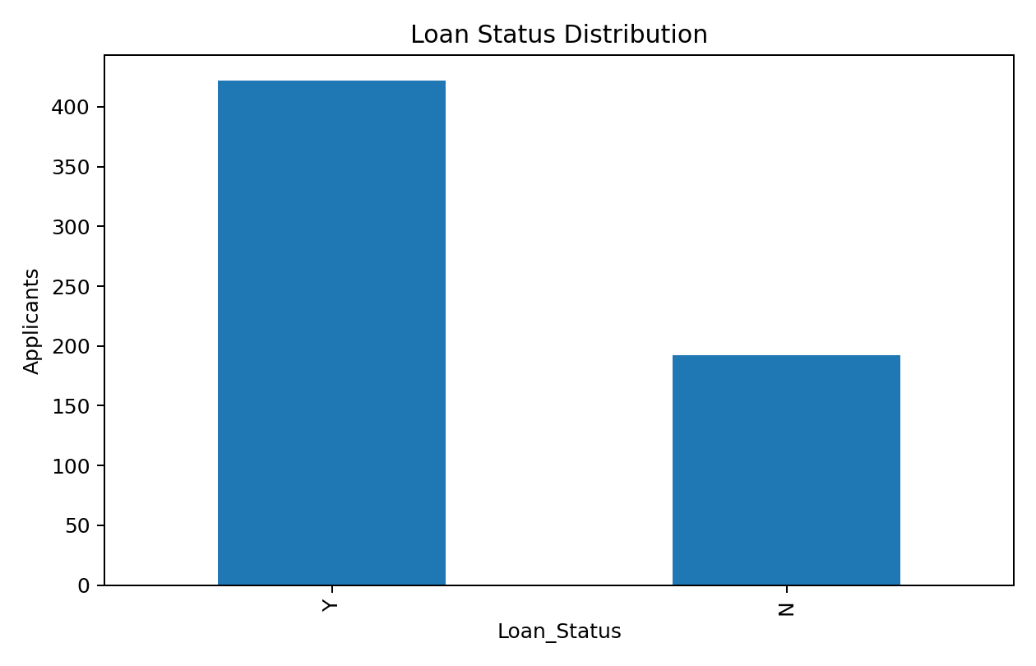
Feature | Mean | Median | Maximum
ApplicantIncome | 5403.4593 | 3812.5000 | 81000.0000
CoapplicantIncome | 1621.2458 | 1188.5000 | 41667.0000
LoanAmount | 146.4122 | 128.0000 | 700.0000
Loan_Amount_Term | 342.0000 | 360.0000 | 480.0000

6. EDA – Bivariate Analysis
Credit history has the strongest observed relationship with loan approval.
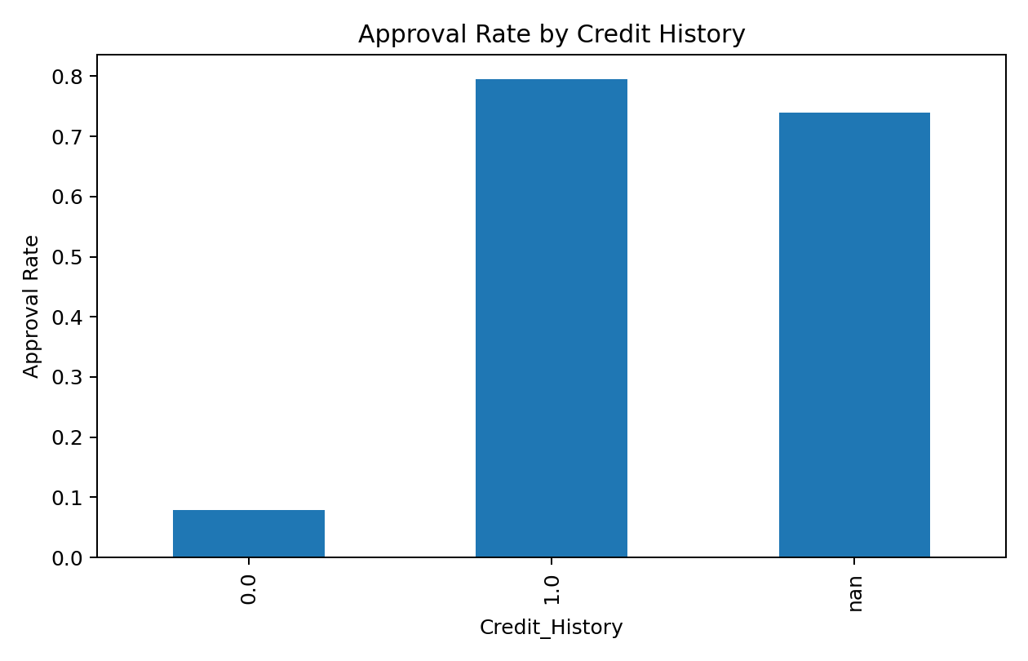
Credit_History | Approval Rate
0.0000 | 7.87%
1.0000 | 79.58%
nan | 74.00%
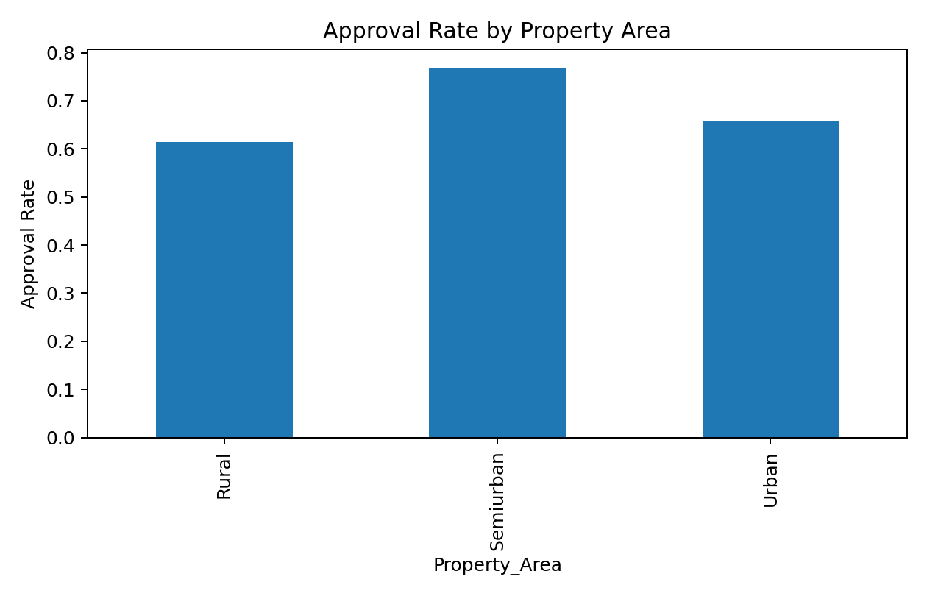

7. Missing Value and Outlier Treatment
Feature | Missing Values
Credit_History | 50
Self_Employed | 32
LoanAmount | 22
Dependents | 15
Loan_Amount_Term | 14
Gender | 13
Married | 3
Numerical variables are median-imputed and categorical variables are most-frequent imputed inside a leakage-safe preprocessing pipeline. High-value observations are not blindly deleted; log and ratio features are used to reduce skewness and represent financial burden.

8. Evaluation Metrics
Accuracy: overall percentage correct.
Precision: correctness of predicted approvals.
Recall: percentage of actual approvals identified.
F1 Score: harmonic mean of precision and recall.
ROC-AUC: ranking/discrimination ability across thresholds.

9. Model Building – Part 1
The classifiers were evaluated using a stratified 80/20 holdout split.
Model | Accuracy | Precision | Recall | F1 | ROC-AUC
Logistic Regression | 0.8699 | 0.8485 | 0.9882 | 0.9130 | 0.8511
Gradient Boosting | 0.8699 | 0.8710 | 0.9529 | 0.9101 | 0.8910
SVM | 0.8537 | 0.8317 | 0.9882 | 0.9032 | 0.8579
KNN | 0.8455 | 0.8367 | 0.9647 | 0.8962 | 0.8328
Decision Tree | 0.8293 | 0.8333 | 0.9412 | 0.8840 | 0.8754
Random Forest | 0.6911 | 0.6911 | 1.0000 | 0.8173 | 0.8579
Extra Trees | 0.6911 | 0.6911 | 1.0000 | 0.8173 | 0.8703
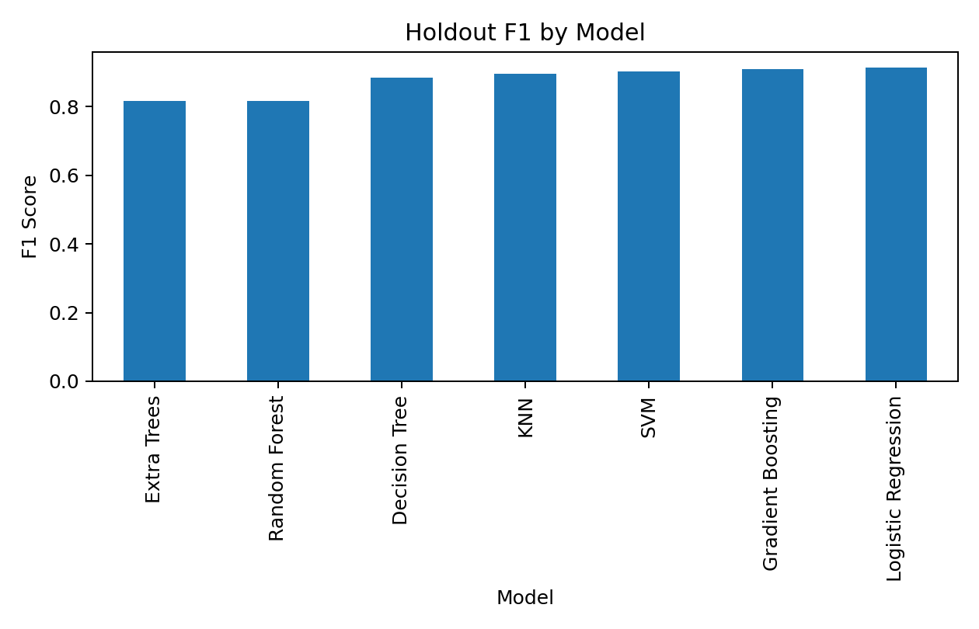

10. Feature Engineering
- TotalIncome = ApplicantIncome + CoapplicantIncome
- Log-transformed income and loan amount
- IncomePerDependent
- LoanAmountPerIncome
- EMI_Proxy
- Credit_History_Missing

11. Model Building – Part 2 / Cross-Validation
Five-fold stratified cross-validation was used for a more reliable estimate of generalization performance.
Model | CV Accuracy | CV Precision | CV Recall | CV F1 | CV ROC-AUC
SVM | 0.8062 | 0.7910 | 0.9764 | 0.8739 | 0.7726
Gradient Boosting | 0.8079 | 0.8009 | 0.9597 | 0.8729 | 0.7806
Logistic Regression | 0.7997 | 0.7952 | 0.9550 | 0.8676 | 0.7595
Decision Tree | 0.7964 | 0.7961 | 0.9478 | 0.8649 | 0.7501
KNN | 0.7899 | 0.7901 | 0.9455 | 0.8608 | 0.7428
Random Forest | 0.6873 | 0.6873 | 1.0000 | 0.8147 | 0.7705
Extra Trees | 0.6873 | 0.6873 | 1.0000 | 0.8147 | 0.7611

12. Final Model Selection
The recommended final model is SVM. It was selected using cross-validated F1 performance. CV Accuracy = 80.62%, CV Precision = 79.10%, CV Recall = 97.64%, CV F1 = 87.39%, CV ROC-AUC = 77.26%.

13. Feature Importance
Feature | Importance
Credit_History | 0.2726
Property_Area | 0.0435
LoanAmountPerIncome | 0.0411
CoapplicantIncome | 0.0325
ApplicantIncomeLog | 0.0252
Dependents | 0.0085
CoapplicantIncomeLog | 0.0069
Married | 0.0063
TotalIncomeLog | 0.0060
IncomePerDependent | 0.0056

14. Test Prediction
Prediction | Count | Percentage
Approved (Y) | 308 | 83.92%
Rejected (N) | 59 | 16.08%
Total | 367 | 100.00%

15. Conclusion
The project implements the requested end-to-end loan eligibility classification workflow. Credit history is the dominant predictor, while total income and loan-burden features add useful information. The final model is intended for academic demonstration; production lending would require policy validation, fairness testing, explainability, monitoring and regulatory review.

